NAME : KEDAR GHULE

CLASS : SE IT A

BATCH: A2

ROLL NUMBER : 3164036

TITLE: Block transfer of data using microcontroller 8051

A] Internal RAM to Internal RAM Transfer

ORG 0000H

MOV R3,#05H

MOV R0,#40H ;SOURCE ADDRESS IN RAM

MOV R1,#50H ;DESTINATION ADDRESS IN RAM

UP:MOV A,@R0 ;COPYING VALUE IN R0 TO ACCUMULATOR

MOV @R1,A ;COPYING VALUE IN ACCUMULATOR TO R1

INC R0

INC R1

DJNZ R3,UP

OUTPUT:

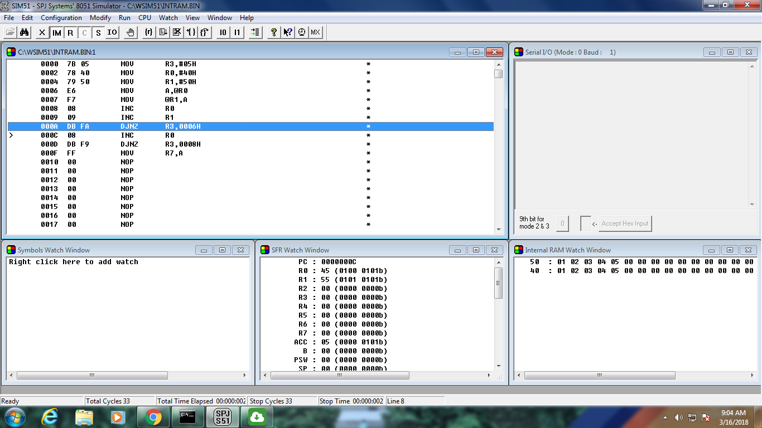

B] Internal RAM to External RAM transfer

ORG 0000H

MOV R3,#05H

MOV R0,#40H ;SOURCE ADDRESS IN INTERNAL RAM

MOV R1,#50H ;DESTINATION ADDRESS IN EXTERNAL RAM

UP:MOV A,@R0

MOVX @R1,A ;TRANSFER TO ADDRESS IN EXTERNAL RAM USING MOVX

INC R0

INC R1

DJNZ R3,UP

OUTPUT:

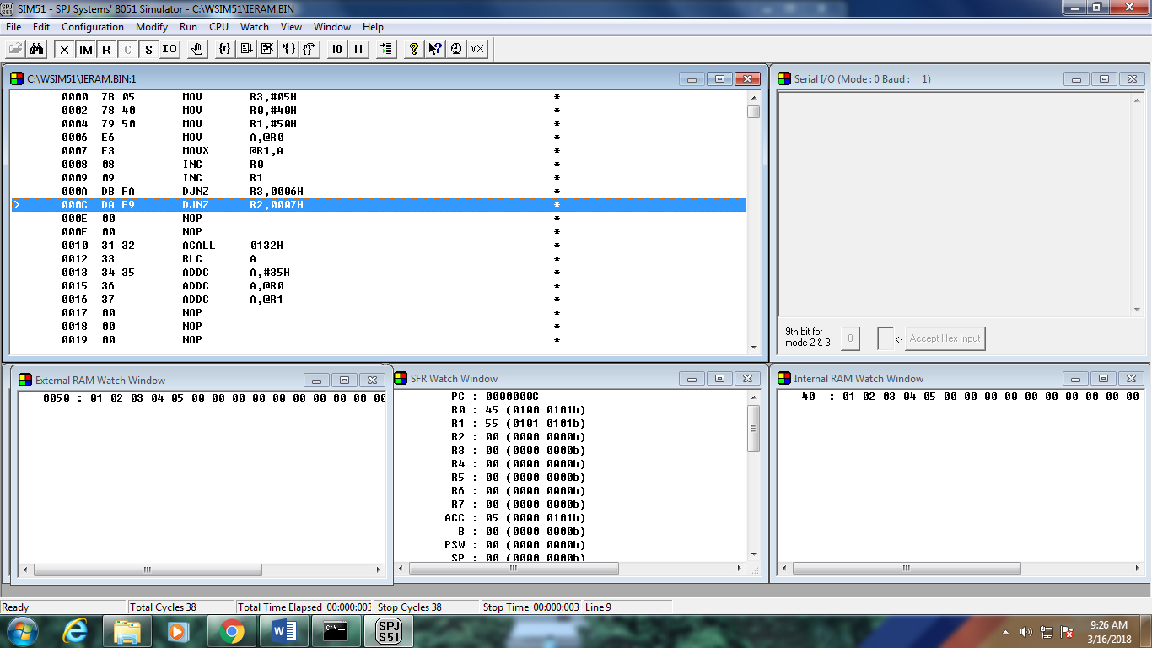

C] Internal ROM to Internal RAM Transfer

ORG 0000H

MOV DPTR,#0010H

MOV R0,#50H ;DESTINATION ADDRESS(INTERNAL RAM)

MOV R2,#07H

UP: CLR A ;CLEAR ALL BITS OF ACCUMULATOR TO ZERO

MOVC A,@A+DPTR ;TRANSFER OF CONTENTS FROM ROM TO ACCUMULATOR

MOV @R0,A

INC DPTR

INC R0

DJNZ R2,UP

ORG 0010H

MYDATA: DB '1','2','3','4','5','6','7' ;DATA IN INTERNAL ROM

OUTPUT:

